**Lab Session 11**

**Question 1:**

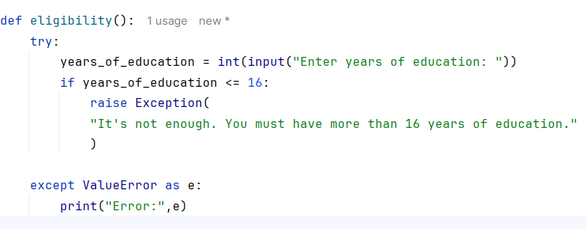**INPUT**

**OUTPUT**

**Question 2:**

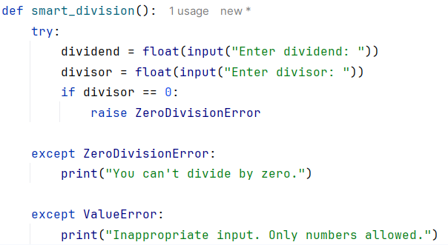**INPUT**

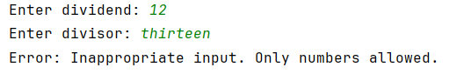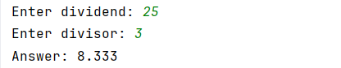**OUTPUT**

**Question 3:**

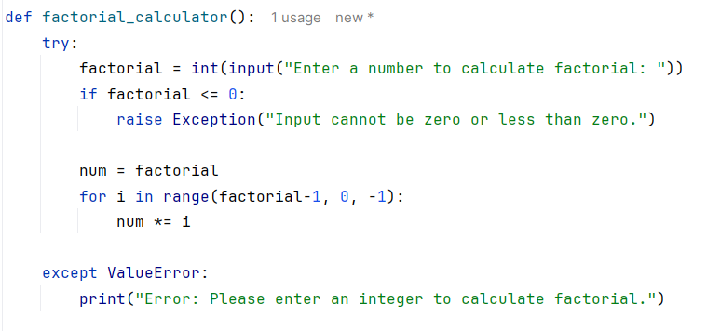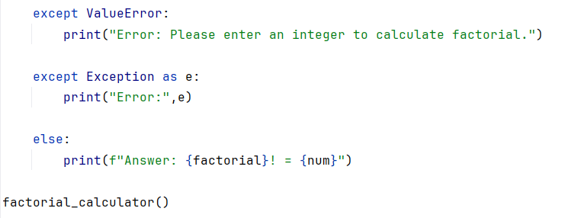**INPUT**

**OUTPUT**

**Question 4:**

**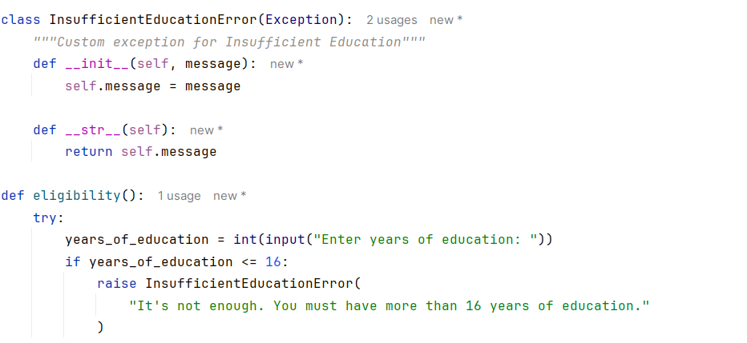INPUT**

**OUTPUT**